Xamarin

TODO

Contents

Introduction 2

# 

# Introduction

The Xamarin application **TUFCv3** *(The Ultimate Fitness Companion)*

is part of the project XWM *(Xamarin, Web server, MySQL)*

XWM is demonstration, including ‘how-to’ documentation,

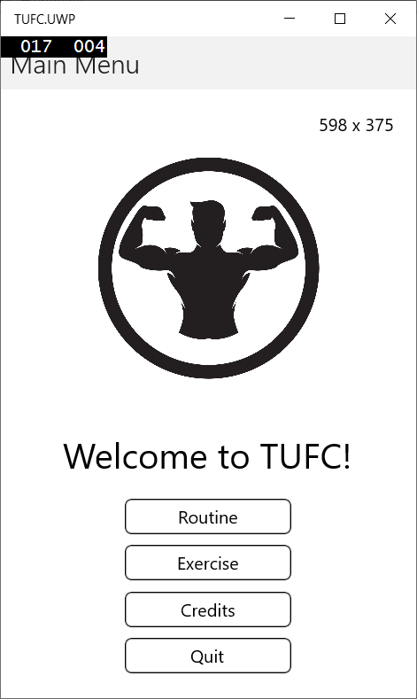bringing these technologies together.

# Create TUFCv3

Create the Xamarin project TUFCv3

in the folder D:\XWM\xamarin

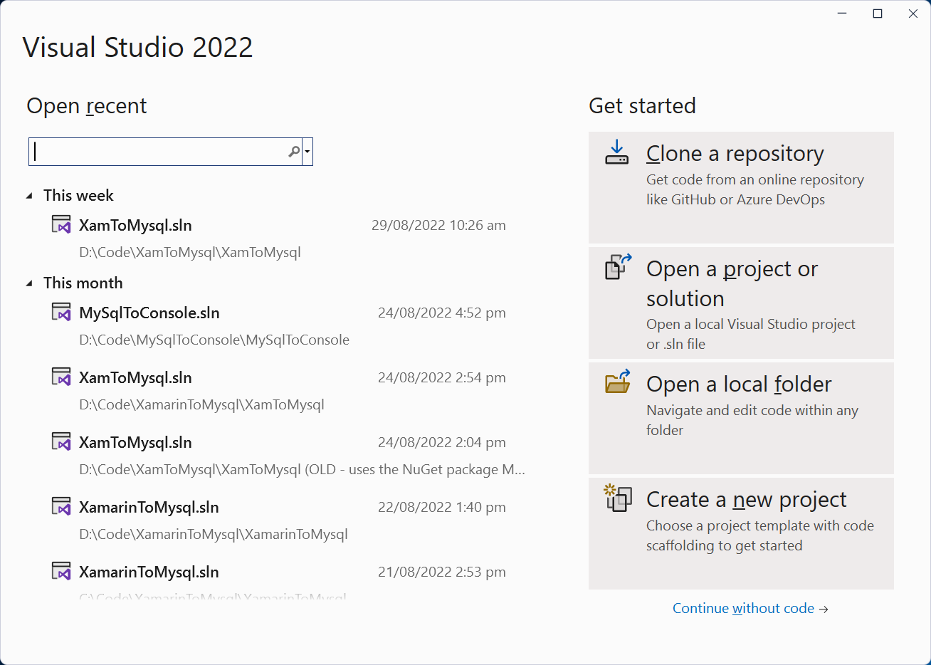

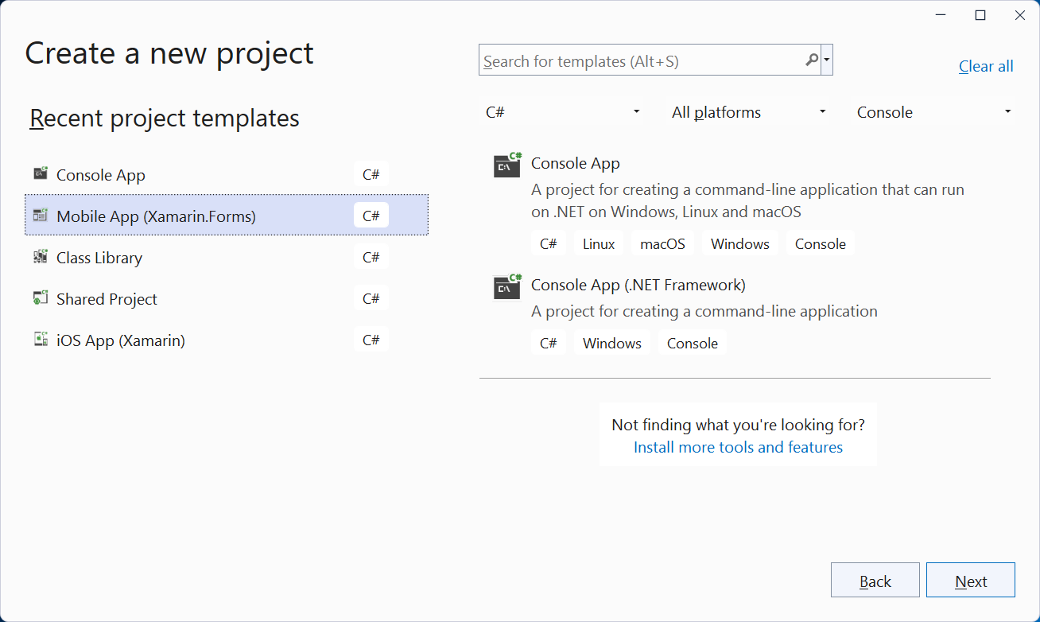

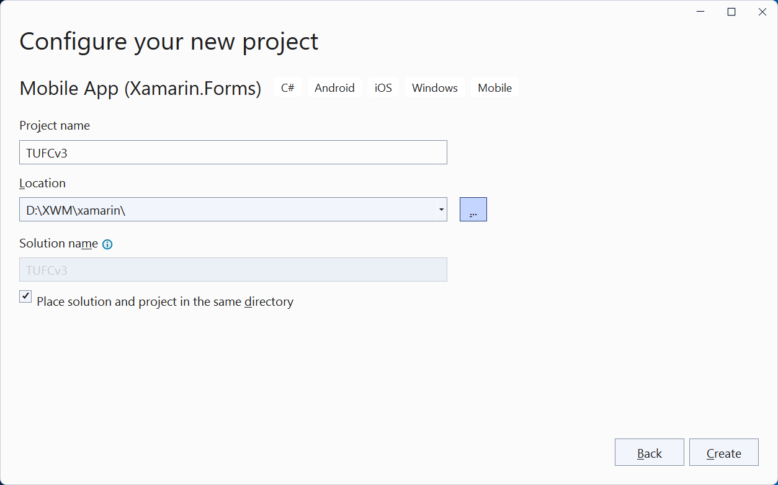

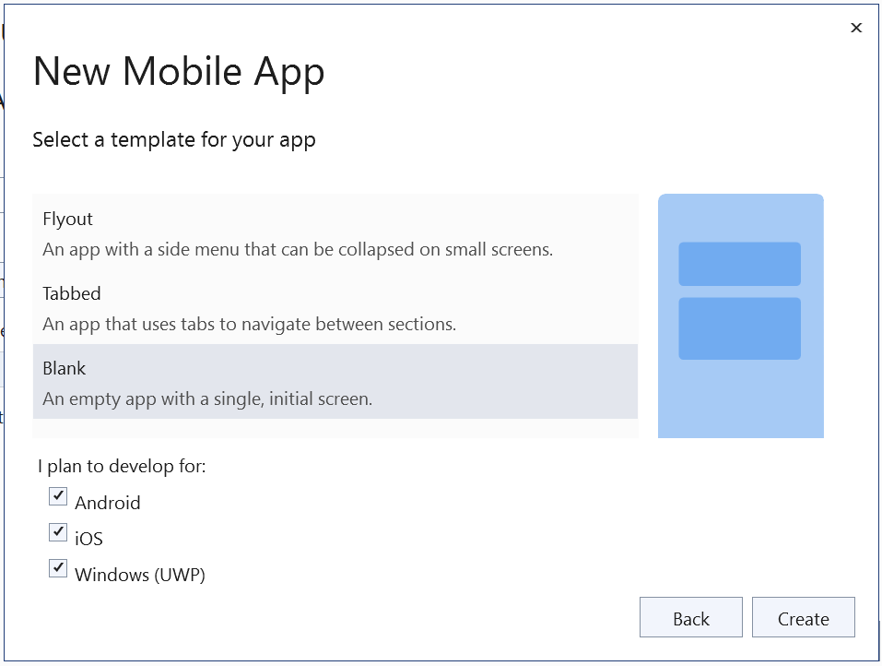

*Next, Update NuGet and run the application …*

## Update Software

Before running the application check for updates on:

* Visual Studio
* NuGet
* Android
* Mac

#### Update Visual Studio

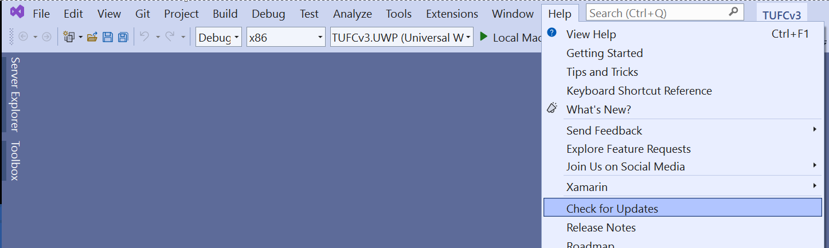

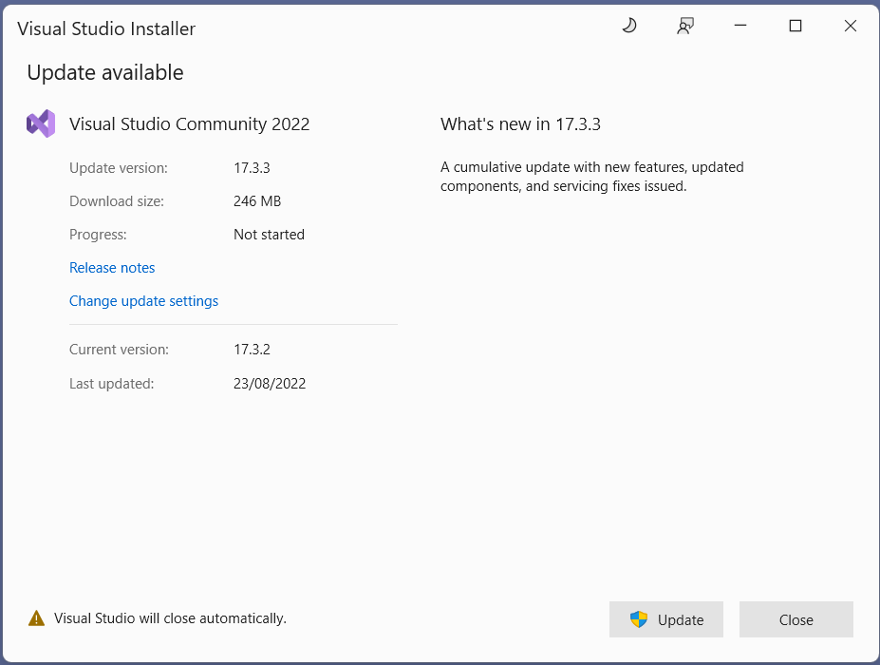

#### NuGet

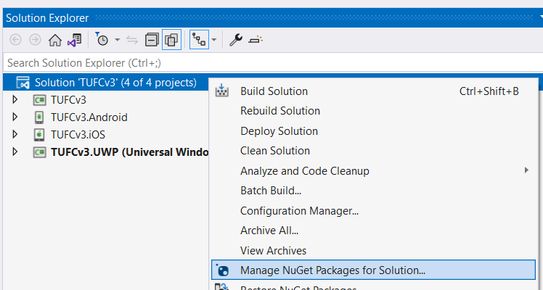

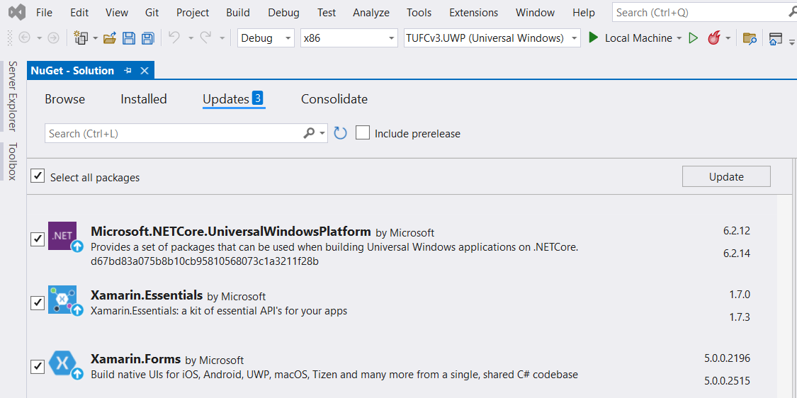

*Next, Android SDK updates …*

#### Android – Check the SDK manager for updates

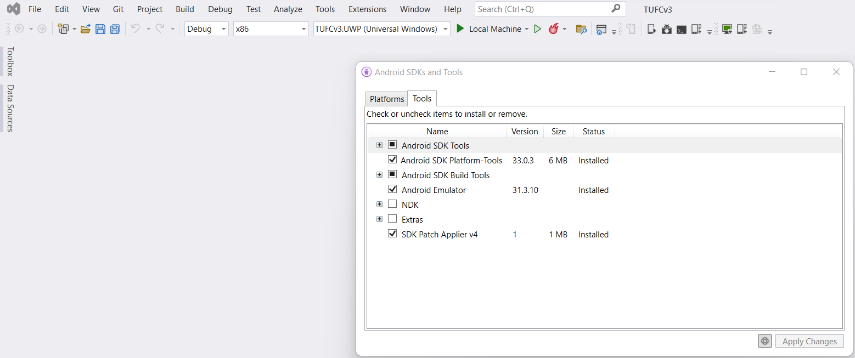

#### Mac

When running iOS emulators on a PC, Visual Studio checks for software compatibility

while pairing with the Mac and updates Xcode versions automatically.

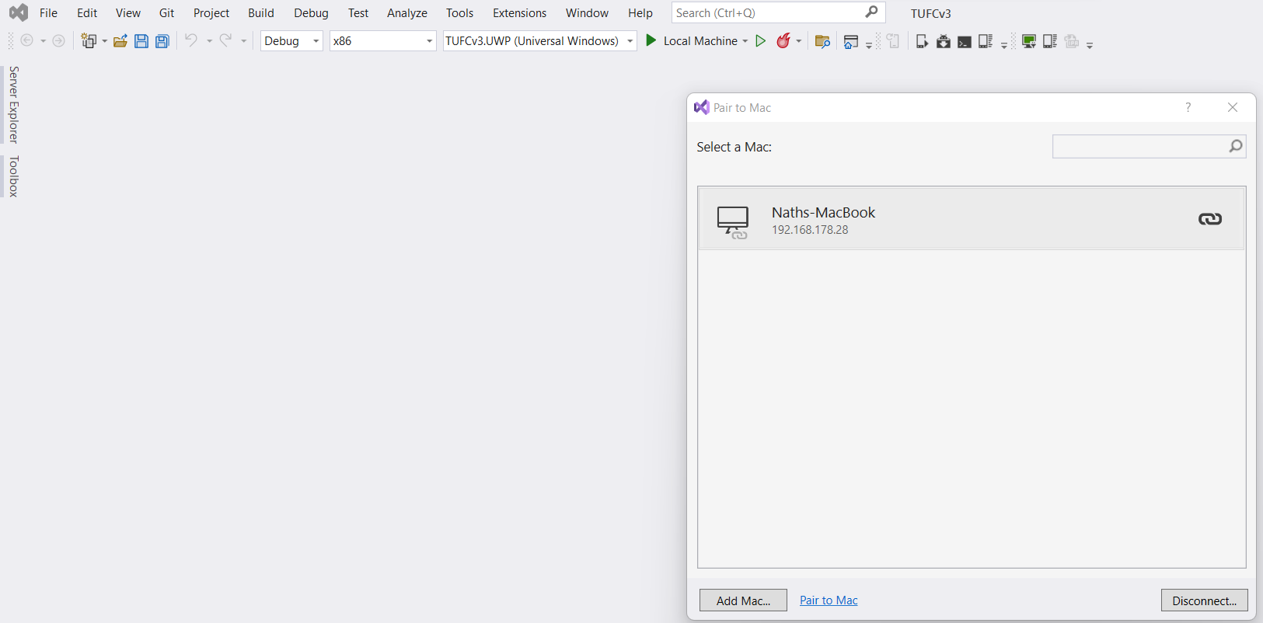

If the PC and Mac pair but the emulator does not start properly

it is worth trying to update the Mac’s operating system.

Although Microsoft, Android and Apple do their best to minimise incompatibility

there may also be times when one company updates software

before compatible software is released by the others.

In this case it is usually a matter of waiting 24 hours

before compatible updates become available,

after which the Android/iOS app will build

and run correctly on the emulator.

## Run the app

Now that the solution TUFCv3 has been created

and software is up to date, run the application.

#### Test – Run the application ‘TUFCv3’

Before making any changes, run the application TUFCv3

to make sure the environment is working correctly - okay

*Android iOS UWP*

